Stages of Sleep Why What and When
REM - NON REM
5 Stages or more
Deep sleep stages 20%
Restorative sleep stages 20%
Brain Wave Patterns
5 x 90 Minute Cycles (8 Hours)
Deep Restorative stages first 2 cycles
11pm > 12.30 > 2am not so much into 3.30am
Light sleep stages Male female
Formative growth years - Adolescence Puberty
The R90 approach simply means recovery in 90 minutes. I haven't randomly picked a number, any number, between one and 100, 90 minutes is the length of time it takes a person under clinical conditions to go through the stages of sleep that constitute a cycle. Our sleep cycles are composed of four (or sometimes five) distinct stages, and it's easy to think about our passage through a cycle as being like a journey down a flight of stairs. When we turn the lights off and get into bed at night, where are at the top of the stairs. Down at the bottom of the stairs is deep sleep, which is where we want to get to.
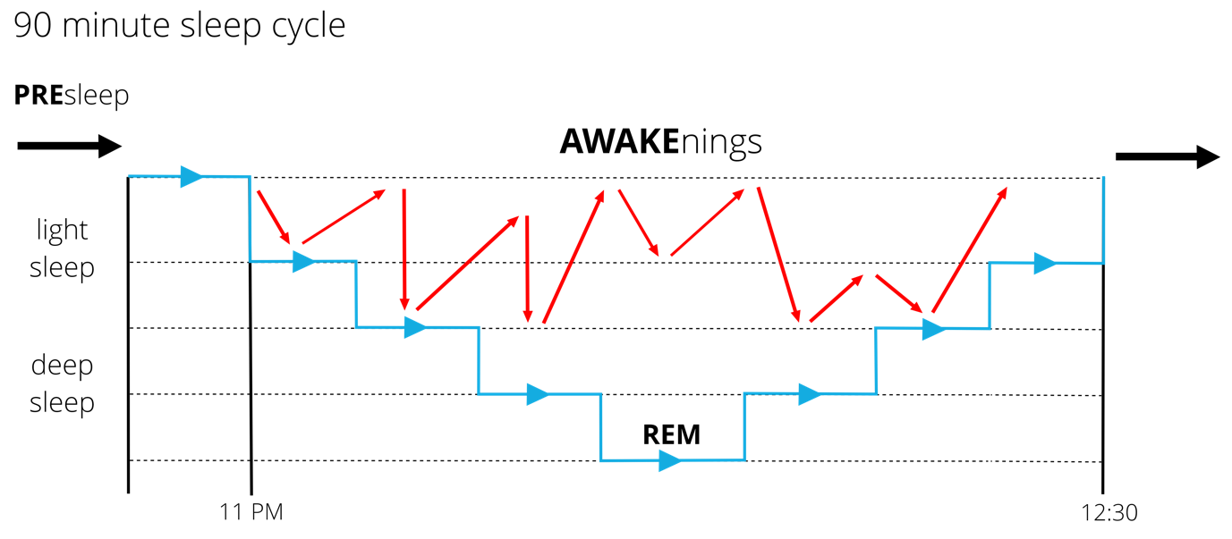
The Top of the Stairs: Dozing off
Non-REM (NREM) Stage 1
We're slowly taking our first couple of steps down the staircase, and we're somewhere between awake and asleep for a few minutes. Have you ever jerked awake suddenly because you've imagined yourself to be falling? That happens here and it's just a hallucination, but it means we need to begin our descent down the stairs again. It's very easy to pull us back up the stairs from here - a door opening, a voice in the street outside will do it - but once we managed to negotiate this stage successfully, we make our way down to …
The Middle of the Stairs: Light Sleep
NREM Stage 2
In light sleep our heart rate slows and our body temperature drops. From here, we can still be dragged back to the top of the stairs by someone shouting our name or, in the case of a mother (and women are biologically susceptible to this), her baby crying. We spend the biggest percentage of our time asleep in this state, so it can feel like a long flight of stairs at times, particularly for those getting stuck in light sleep, but it isn't time wasted if it's part of a well-balanced cycle. Information consolidation and improved motor skills performance is linked to this stage, and as we move further down, we begin the transition to the really good stuff.
The Bottom of the Stairs: Deep Sleep
NREM Stage 3 (and 4)
Congratulations. You've reached the bottom of the stairs. Down here, it takes a good deal of effort to wake us. If you've ever had to shake someone awake, or if you've been unfortunate enough to be on the receiving end and woken up punch drunk and confused, you'll understand the kind of power deep sleep has and the effects of sleep inertia. For the sleepwalkers among us, this is the stage when you will take to the floor.
Our brain produces delta waves, the slowest frequency brain waves (we produce the high frequency beta waves when we are awake) in deep sleep. We want to spend as much time as we can down here, wallowing in it, as this is where we reap the major physical restorative benefits of sleep, such as the increase in our release of growth hormone. Human growth hormone (HGH) might be familiar to some readers as a banned performance enhancing drug in sport, but our bodies produce it naturally, and its effects are powerful. Dr Michael J. Breus, a clinical psychologist and sleep expert in the USA, describes it as ‘a key ingredient we all need routinely to grow new cells, repair tissues, recover our bodies from the daily grinds, and essentially be (and feel) rejuvenated’. We hope to spend around 20% of our time down here in deep sleep during the night.
Helter Skelter: REM
In The Beatles’ song ‘Helter Skelter’, they sing of going back up to the top of the slide, where they stop and turn and go for a ride. It's not too dissimilar to this stage of sleep. We head back up the stairs, to light sleep territory for a while, before we reach a stage of sleep many of us are familiar with: REM (Rapid Eye Movement). This is where our mind takes us off on a ride - we do most of our dreaming in this stage while our bodies are temporarily paralysed , and REM sleep is believed to have beneficial effects on creativity. We need to get back up towards the top, stop and turn and go for a ride every bit as much as we need to get to the bottom of the stairs, and again, we should look to spend around 20% of our time in this stage. Infants spend more like half their time asleep here. At the end of the REM stage we wake - we usually won't remember this - before beginning the next cycle.
Each cycle during the night is different. Deep sleep accounts for a higher proportion of our sleep in earlier cycles, as our body prioritises getting this as soon as it can, while REM sleep accounts for a higher proportion in later cycles. However, if we have been getting less sleep than normal, our brain will drop into REM for longer in earlier cycles, demonstrating its importance to us. This is just one of the reasons why catching up on sleep - by going to bed earlier than normal or sleeping in later - is a waste of your time. Once sleep has been lost, it's gone. But our bodies are remarkably good at doing our catching up for us.
Ideally, we would spend a night in bed smoothly making the transition from one cycle to the next, in a pattern of sleep-wake-sleep-wake… gradually getting less deep sleep and more REM sleep as the night progresses, until our final wake in the morning. This is the key to getting the right quality of sleep: all the light sleep, deep sleep and REM we need in a series of cycles which feels to us like one long continuous night’s sleep.
However, there are all sorts of obstacles in our way: noise, age, stress, medication, caffeine, physical disturbances like a partner’s leg touching us, breathing through our mouth instead of our noses, snoring and sleep apnoea, temperature and the necessity of a bathroom visit can bring us back up towards the top of the stairs and leave some of us doomed to spend too much of the night in the lightest stages of sleep, or take us out of our cycles entirely.
The knock-on effects of this can range from growing levels of daytime fatigue to fatal consequences. Our bodies can dump us straight down into a microsleep during the day when we least expect it, such as when driving a car or operating a piece of machinery.
If we are trapped in light sleeping patterns then it doesn't matter how much sleep we're getting - were not benefiting from it fully. The R90 approach tackles obstacles that stop us getting down the stairs. Learn more about R90 Coaching here.

